Van Isle Waterproofing+
Last updated: August 10, 2026
Warehouse Wizard
https://docs.google.com/spreadsheets/d/1EKxNsSK7GyZ3OYhTupU9XLWnv9tgj79SoyFF-jE0Ck0/edit?gid=728197960#gid=728197960
UPDATED: The missing inputs listed below will be ready by August 18.
TESTING: We will test the live site and provide input and feedback August 19 & 20.
CREW USE: We want to have the tool live and ready for the team to log in and use by August 21.
A. Inventory & warehouse data (Warehouse Wizard)
🔴 A1. Finish the inventory spreadsheet

Missing Inputs as of August 10

On Hand (current quantity) Inventory at warehouse — We will provide any inventory that needs to be logged under column J. If this column is blank after our deadline, we do not need to log the items strictly. We only need to log high-value items.
INVENTORY LOG - Column D under daily inventory should only have 4 options. Default all items to UNIT if they don’t fit into these categories.
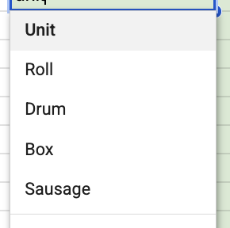
Tools - Will be updated with our real tools
Trucks - See note re users. Not everyone will be responsible for doing the tasks on list, only the person who logs in and checks off the tasks that day will earn points, given any user who uses the tool the ability to earn points. If someone doesn’t login and check off items, they just won’t earn points as they’re not taking action.
We had a scenario today where the crew member didn’t check the gas at the warehouse and got to the site and ran out of gas. The manager had to take an hour out of his day to get him gas so the truck could make it to the closest gas station. This is why we’re creating these check lists, to help them from making silly mistakes and to save everyone time by being properly prepared at the beginning of the day and prepared for the next day by doing things right before they head home.

CREW+
UPDATED: The missing inputs listed below will be ready by August 25
TESTING: We will test the live site and provide input and feedback August 26 & 27
CREW USE: We want to have the tool live and ready for the team to log in and use by August 28

Missing Inputs
Values
https://docs.google.com/spreadsheets/d/16AbPesjyoZBDwveNqBIF8PXgHBf3X2V5/edit?gid=1104378483#gid=1104378483
OUR VALUES: Helpful | Clear | Professional
- Your safety is of the utmost importance. If you feel unsafe at any time during your workday, stop. Present the issue to the most senior Van-Isle team member on-site. That person will contact Jesse Dares, who will speak directly with the site supervisor about the problem.
- Respect everyone. We must be professional in transit and on the job site. This includes how we treat team members, other contractors, and job site staff.
- Relationships matter, and our customers are vital to our success. If you have a comment or concern about a job site, please contact Jordan Rogers so he can address the issue directly with the appropriate parties. Unless otherwise discussed, only Jesse Dare can speak directly with superintendents.
KPI’s
https://docs.google.com/spreadsheets/d/16AbPesjyoZBDwveNqBIF8PXgHBf3X2V5/edit?gid=644441661#gid=644441661
Job Descriptions
https://docs.google.com/spreadsheets/d/16AbPesjyoZBDwveNqBIF8PXgHBf3X2V5/edit?gid=1174754468#gid=1174754468
Nudge & Cadence
https://docs.google.com/spreadsheets/d/16AbPesjyoZBDwveNqBIF8PXgHBf3X2V5/edit?gid=772864037#gid=772864037

New Request
*NEW* Employee Onboarding - Question
When we onboard new hires, they are asked to complete the following PDF. The process os clunky because it means sending a document to them, them printing it, sending it back. Can we use the Crew+ app to onboard new hires by sending them a login & pw and requesting this information from them? Directly via the tool?
They must also upload these items when they are onboarded:
- Direct Deposit Form from your bank
- Photo of your Driver’s License (front & back)
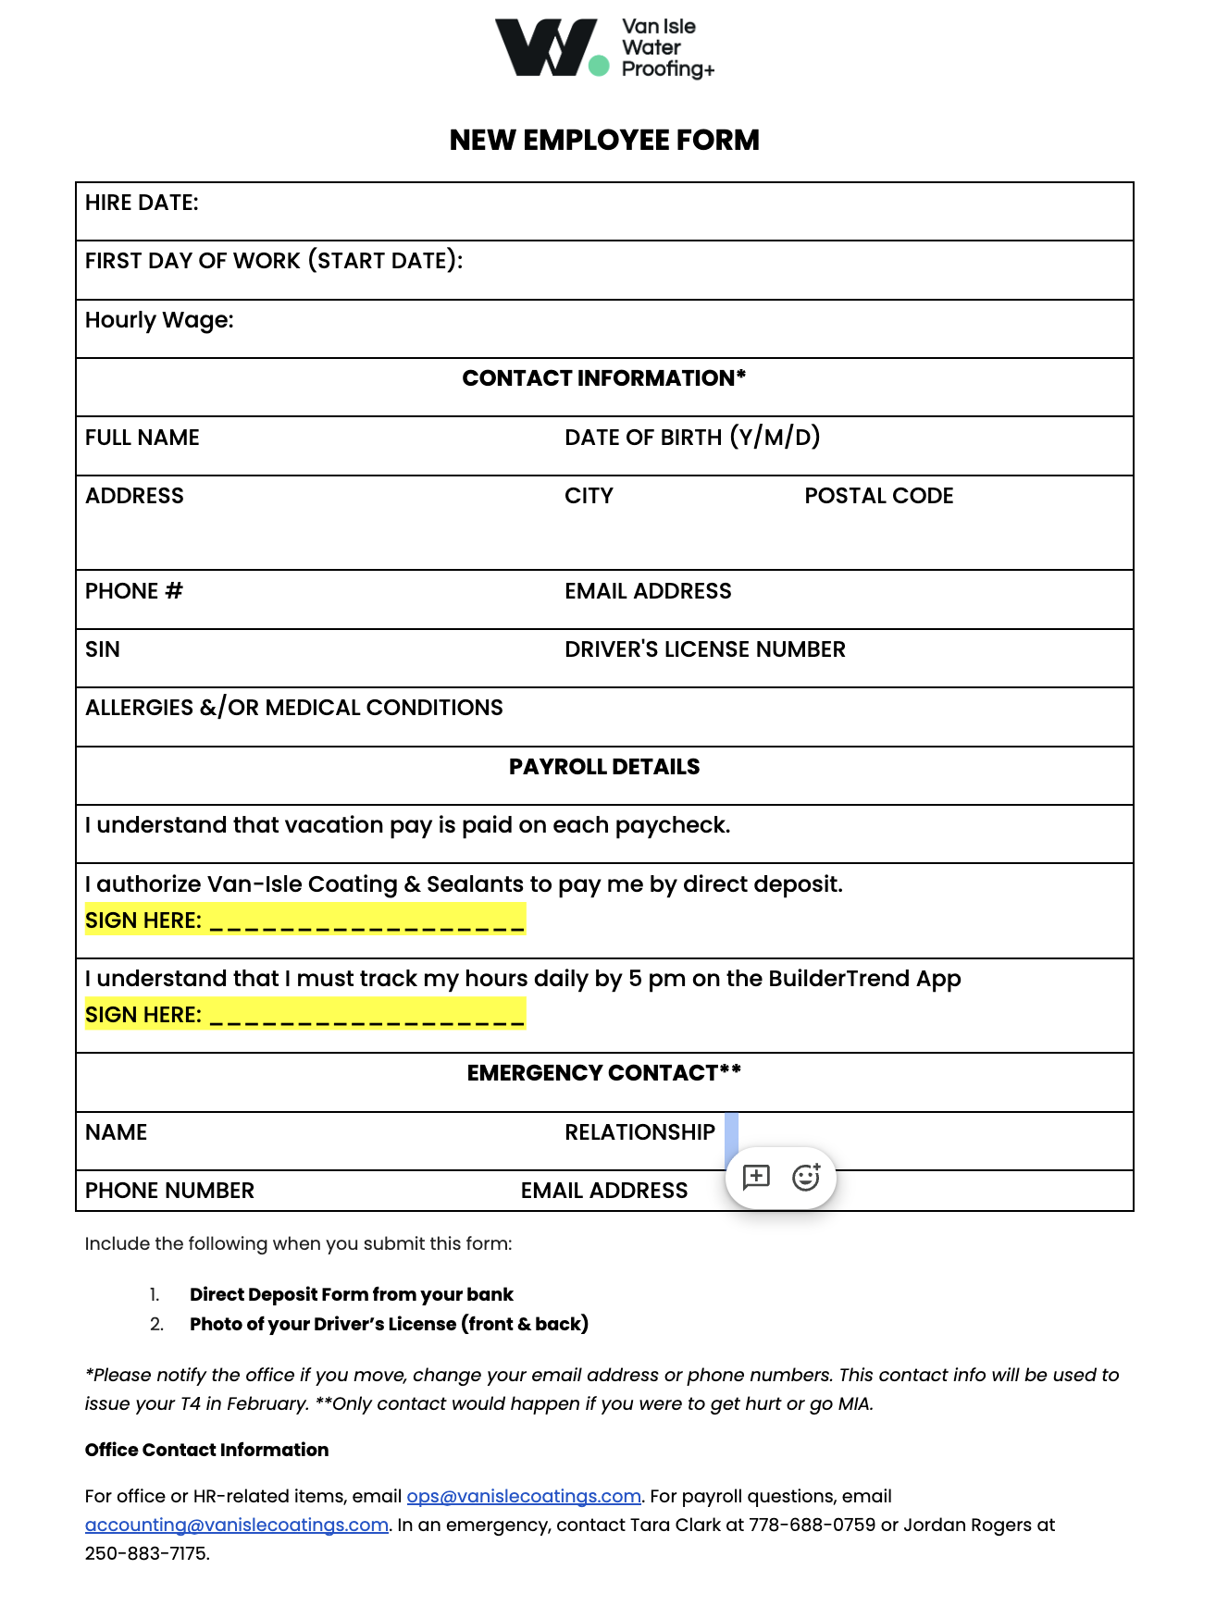
Recently requested items:
People, performance & compliance (Crew+)
SICK & VACATION DAYS
Each member of the crew has 5 paid Sick Days, 3 unpaid sick days & Vacation Days they need to track
Sick Days Eligibility: Applies to full-time, part-time, temporary, and casual workers after 90 consecutive calendar days of employment with the same employer
The crew can use their sick days and vacation time between January 1 to December 31. Then they renew.
The sheet below shares the reminders that need to go out to the crew via email & text to show how many vacation days they have left.
We don’t want to send reminder to use sick days, but definitely vacation days
https://docs.google.com/spreadsheets/d/16AbPesjyoZBDwveNqBIF8PXgHBf3X2V5/edit?gid=20971711#gid=20971711
BULLYING & HARRASSMENT
The crew must sign this document 1x every year. The next deadline should be August 31, 2026 and repeat the reminder annually on this day. They should have to read all of the copy and e-sign and date at the end. You will need the PDF to upload the document to the portal to request a signature.
Added to line 16 here https://docs.google.com/spreadsheets/d/16AbPesjyoZBDwveNqBIF8PXgHBf3X2V5/edit?gid=772864037#gid=772864037
Quarterly Review Program
- See PDF
- Crew updated here: https://docs.google.com/spreadsheets/d/1EKxNsSK7GyZ3OYhTupU9XLWnv9tgj79SoyFF-jE0Ck0/edit?gid=1027071879#gid=1027071879
SWOT
The crew should tell us what our strengths, weaknesses, opportunities and threats are every quarter. The section should be a fillable form with a limit of 500 words per category.
https://docs.google.com/spreadsheets/d/16AbPesjyoZBDwveNqBIF8PXgHBf3X2V5/edit?gid=340726078#gid=340726078
Deadlines to provide their input: September 30, December 31, March 31, June 30
Incident Report
DONE

